|  |  |  |  |  |  |
| --- | --- | --- | --- | --- | --- |
| Date | 11-Dec-22 | | | Tester Name | Mohammad Yusuf |
| Environment | Penfax - Test | | | Login used |  |
| Operating System | Windows | Version: | Update: | | |
| Software Used | Edge | Version: | Update: | | |
| Not Applicable | Version: | Update: | | |
| Release version |  | | | | |
| Title | E7 Fund Transfers | | | | |
| Test Type | Regression | | | | |
| Test Scenario | E7.12 Rebalance the funds to a different percentage in the same funds they are in - PENWEB | | | | |
|  |  | | | | |
| Expected Results | 1. Asset rebalance should be processed and displayed under member’s account in Penfax and in Member PLANet. 2. PEPP Interfund Transfer Letter should be available. 3. Transcation should be listed on the Daily Valuation Report. | | | | |
| Pass/Fail | Pass | | | JIRA# | N/A |

Describe your steps with screenshots:

1. Search active PEPP member having current deposit allocation in more than 1 fund by SQL query.
2. Search for the stakeholder. Click on Stakeholder ID.
3. Click on Investments on the Navigation panel. Scroll down and open up the Account Instructions Tab. Take note of what the current instructions are. Here, the current deposit allocation is AF and MMF. And current investments are in AF, BF and MMF. Click Add.

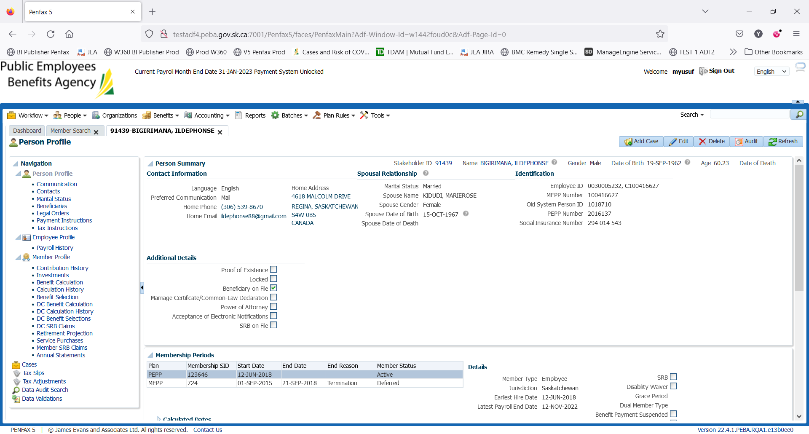

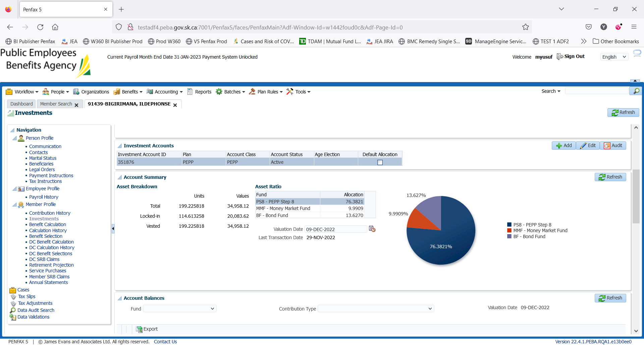

1. Member PLANet -> current allocation

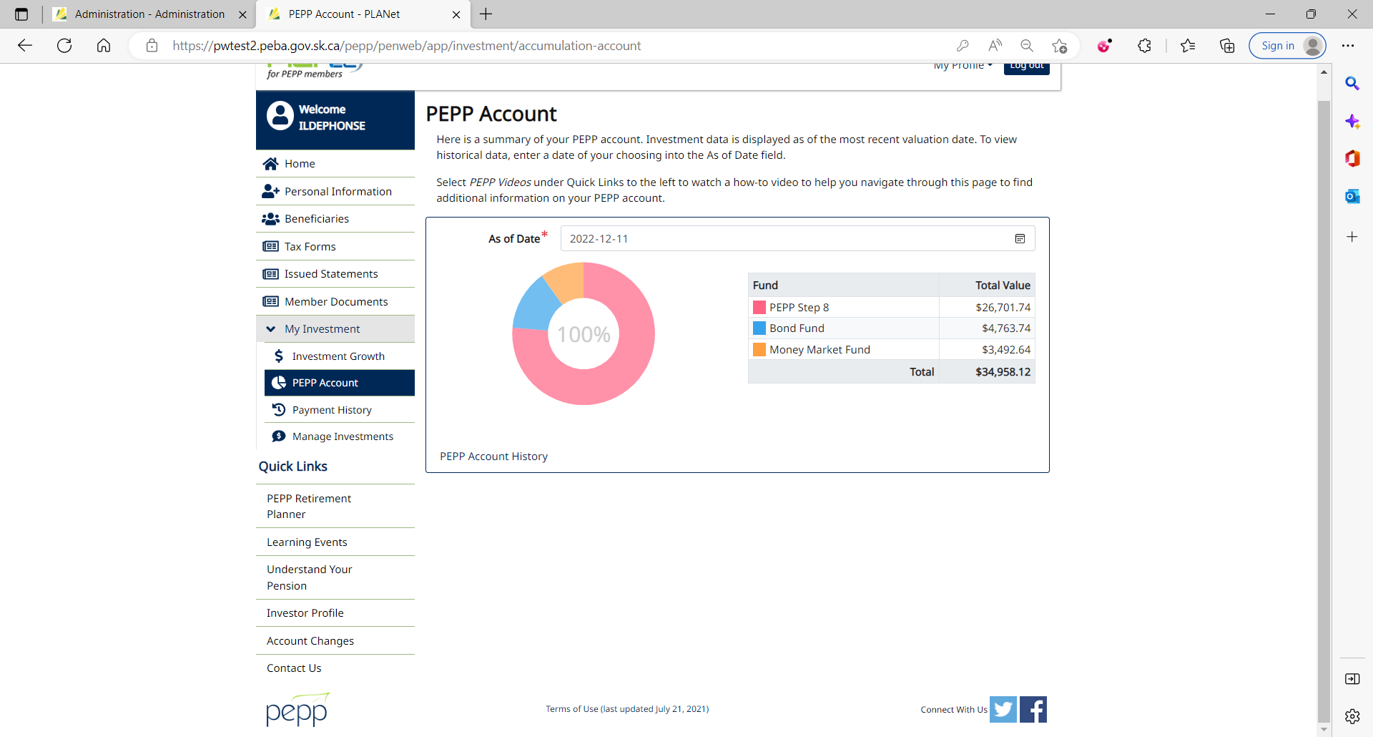

1. Go to Manage Investments to do interfund transfer. Click on Change My Investment Options.

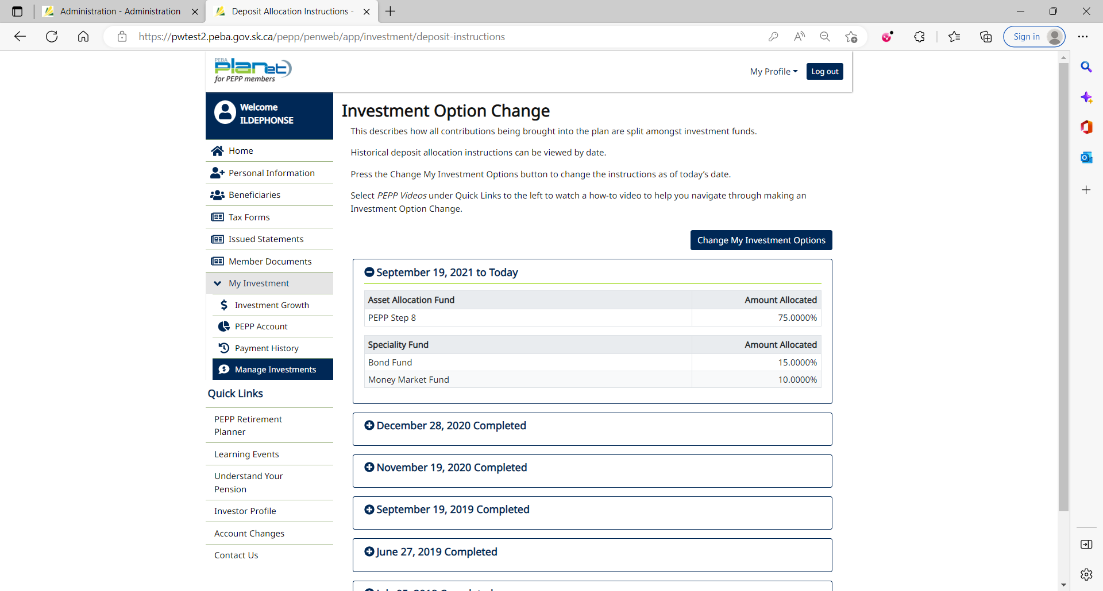

1. Click No.

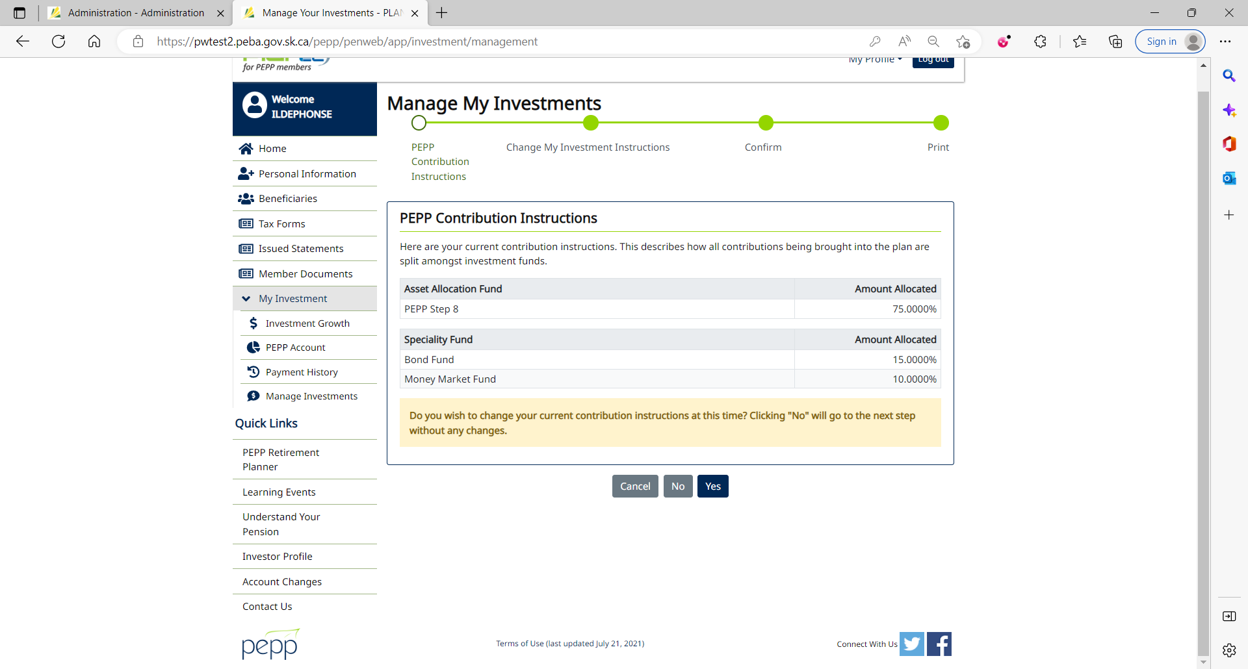

1. Click Yes.

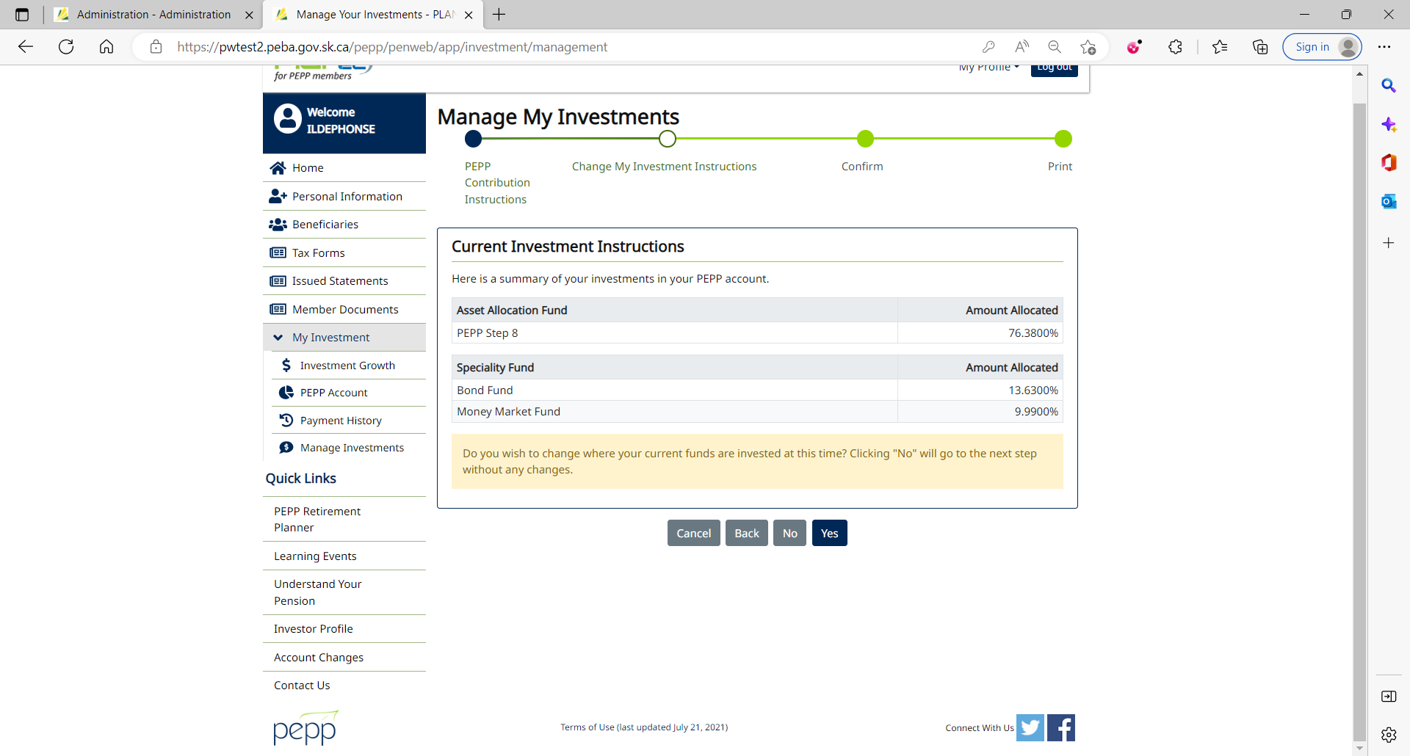

1. Current Investment Instructions

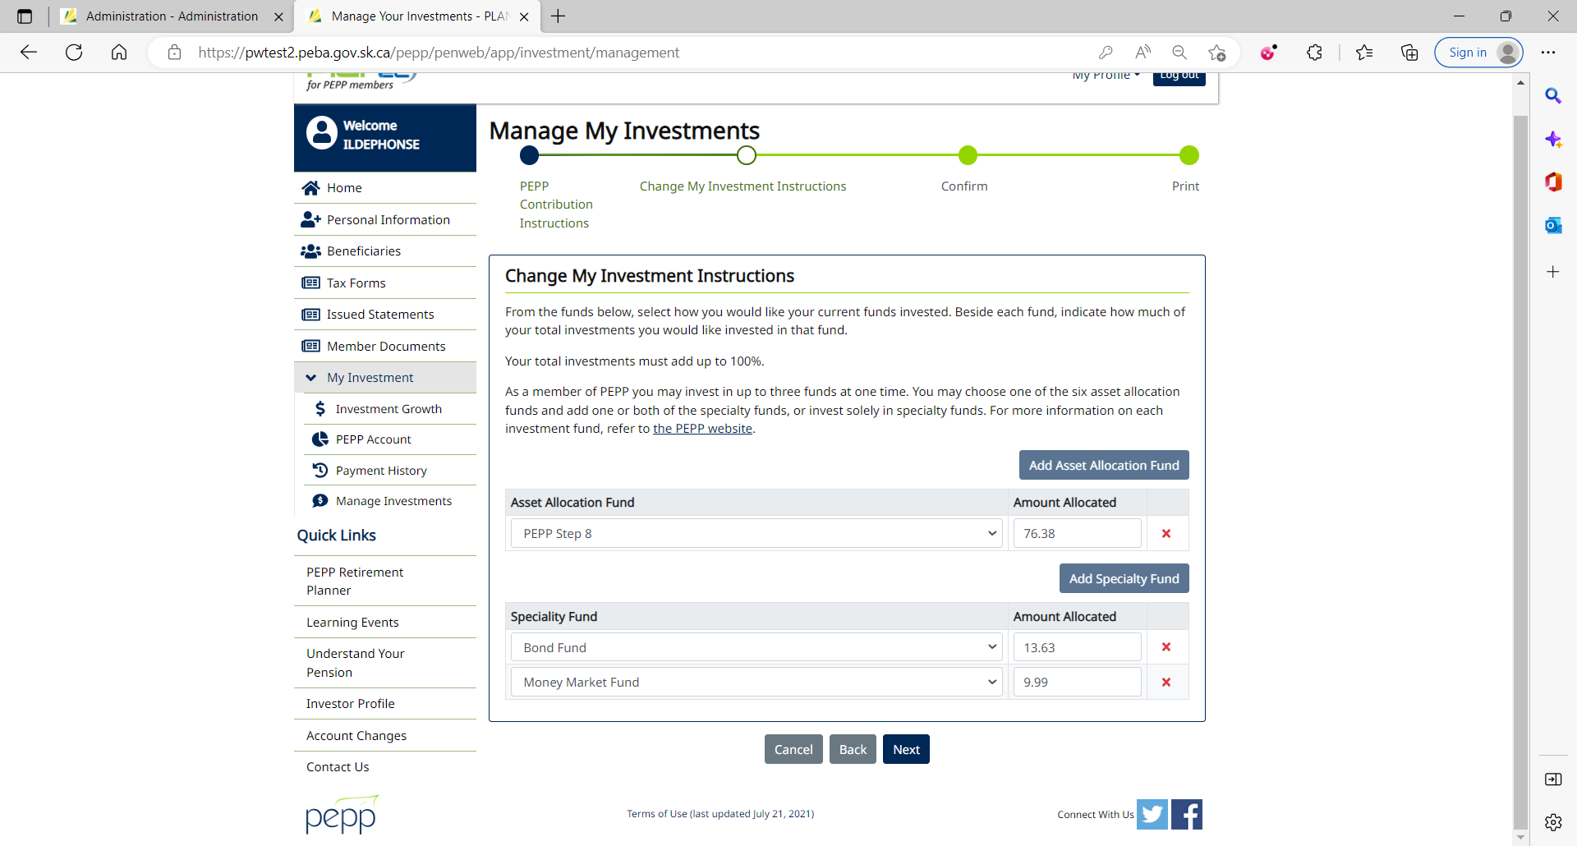

1. Re-allocate the amount to each fund. Click Next.

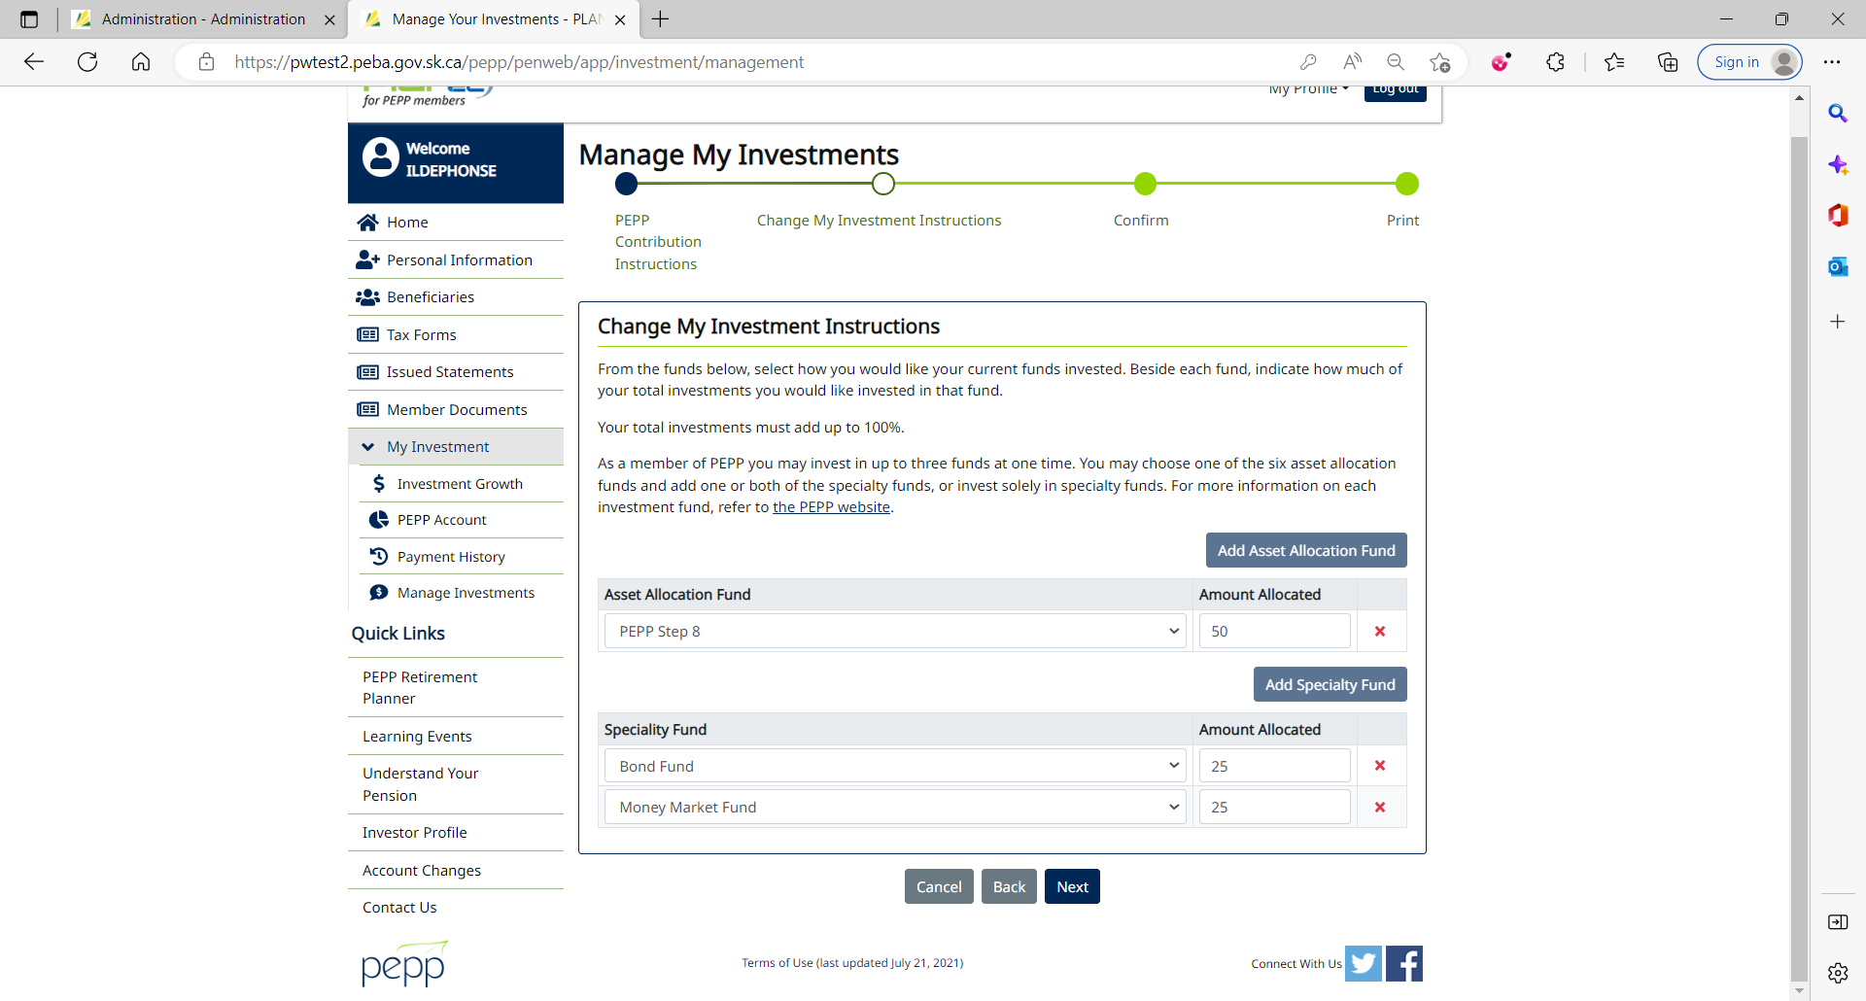

1. Tick the checkbox and click Confirm.

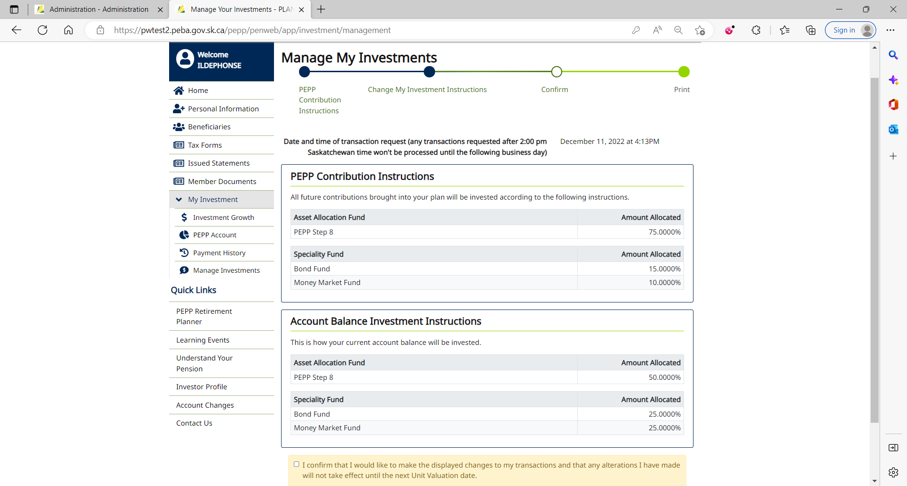

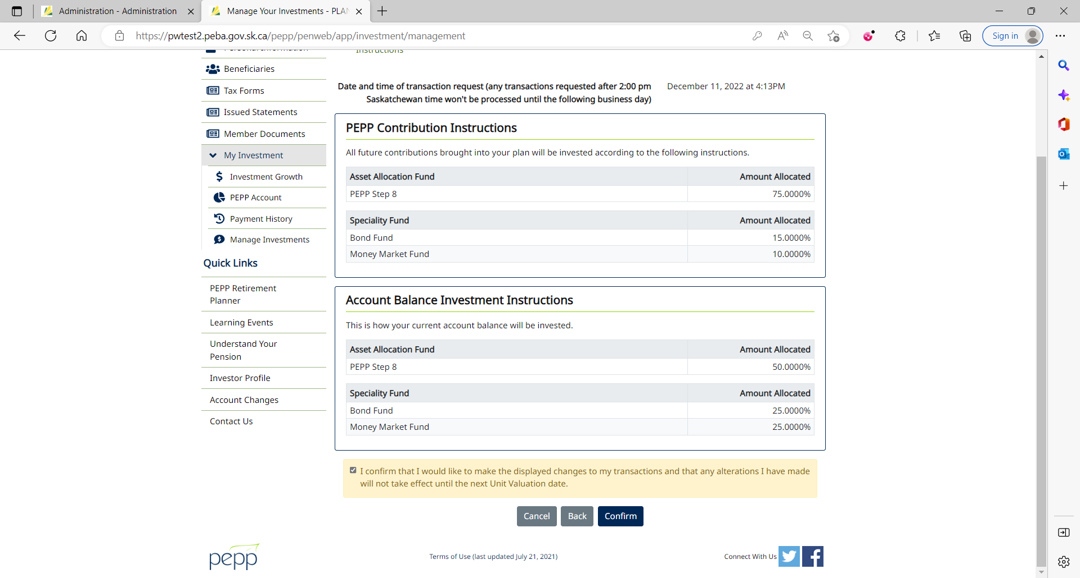

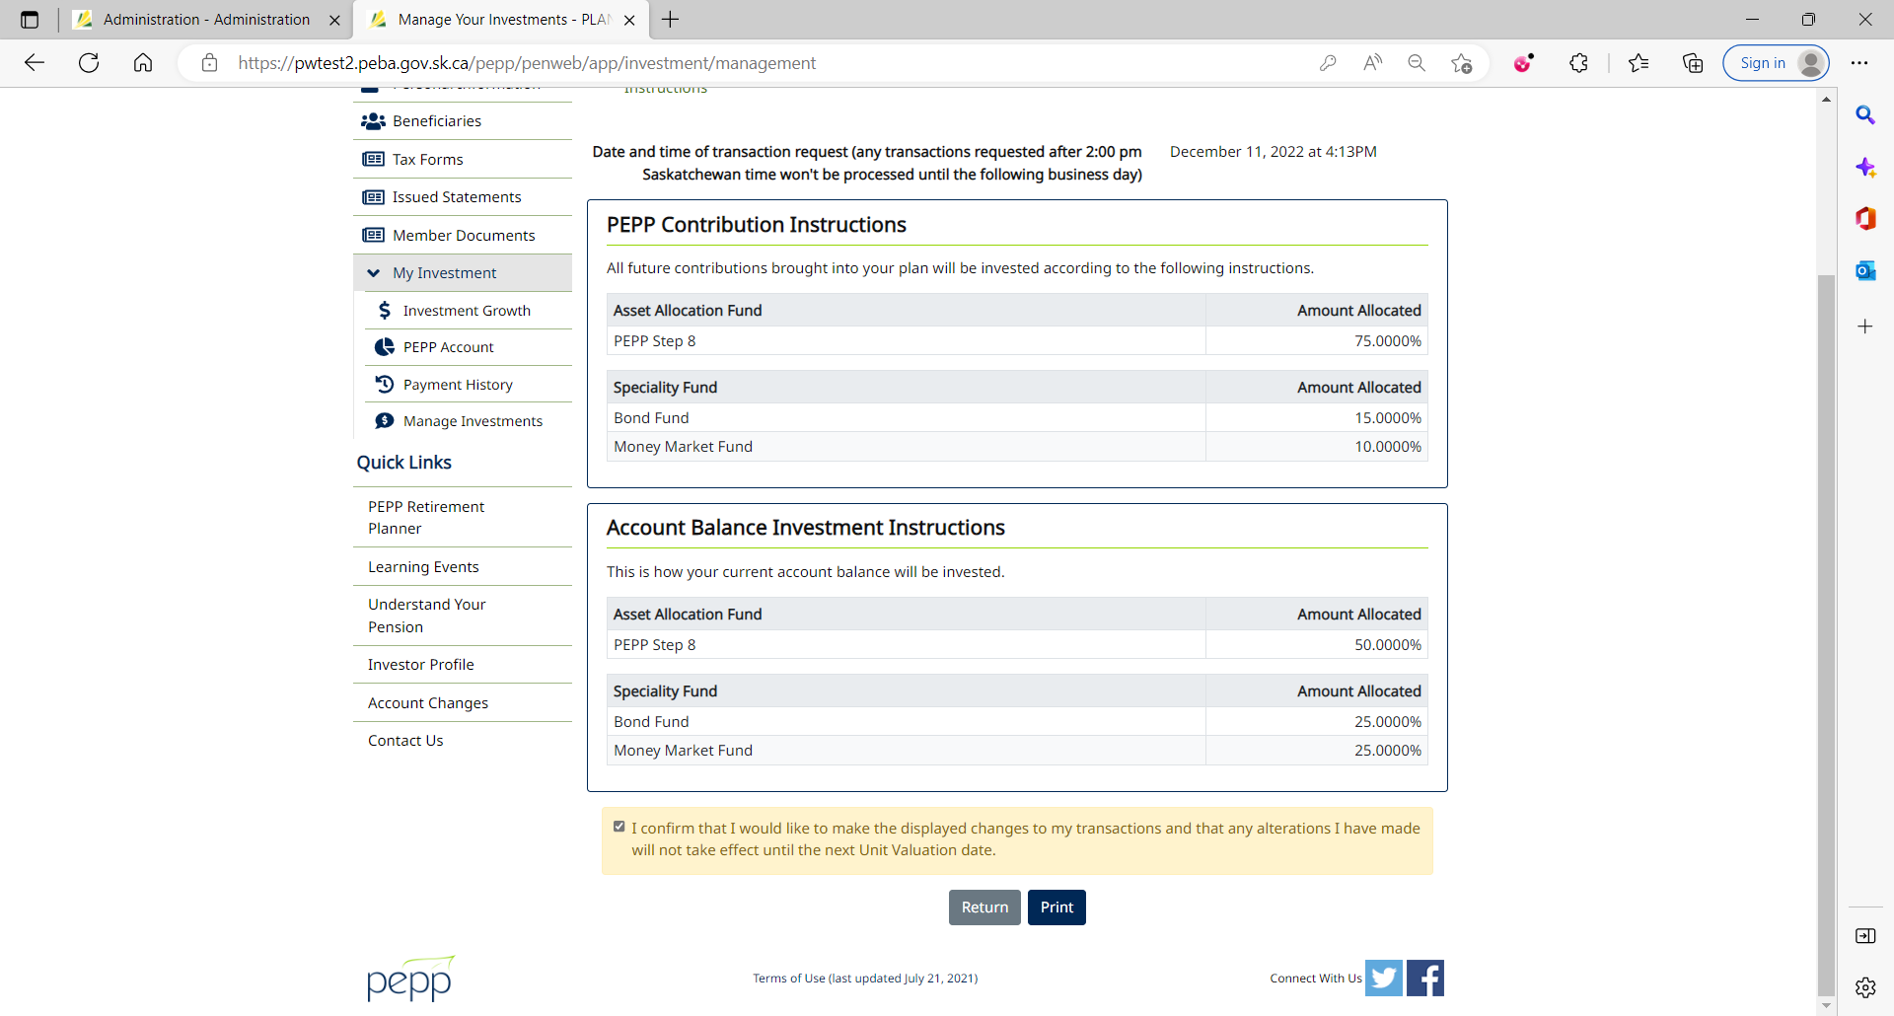

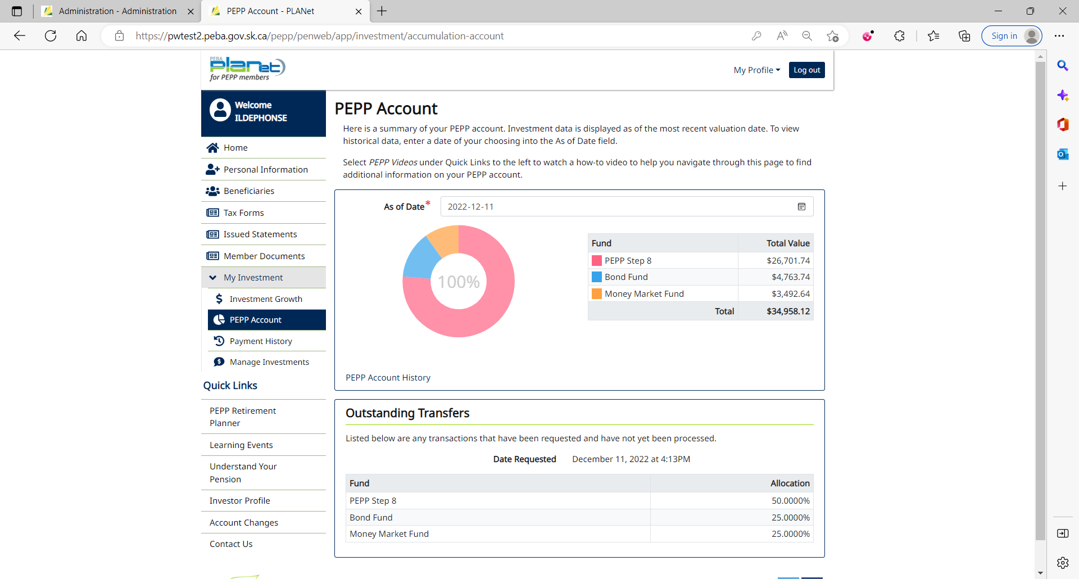

1. Interfund Transfer can immediately be seen under Account Instructions in Penfax with the Pending status.

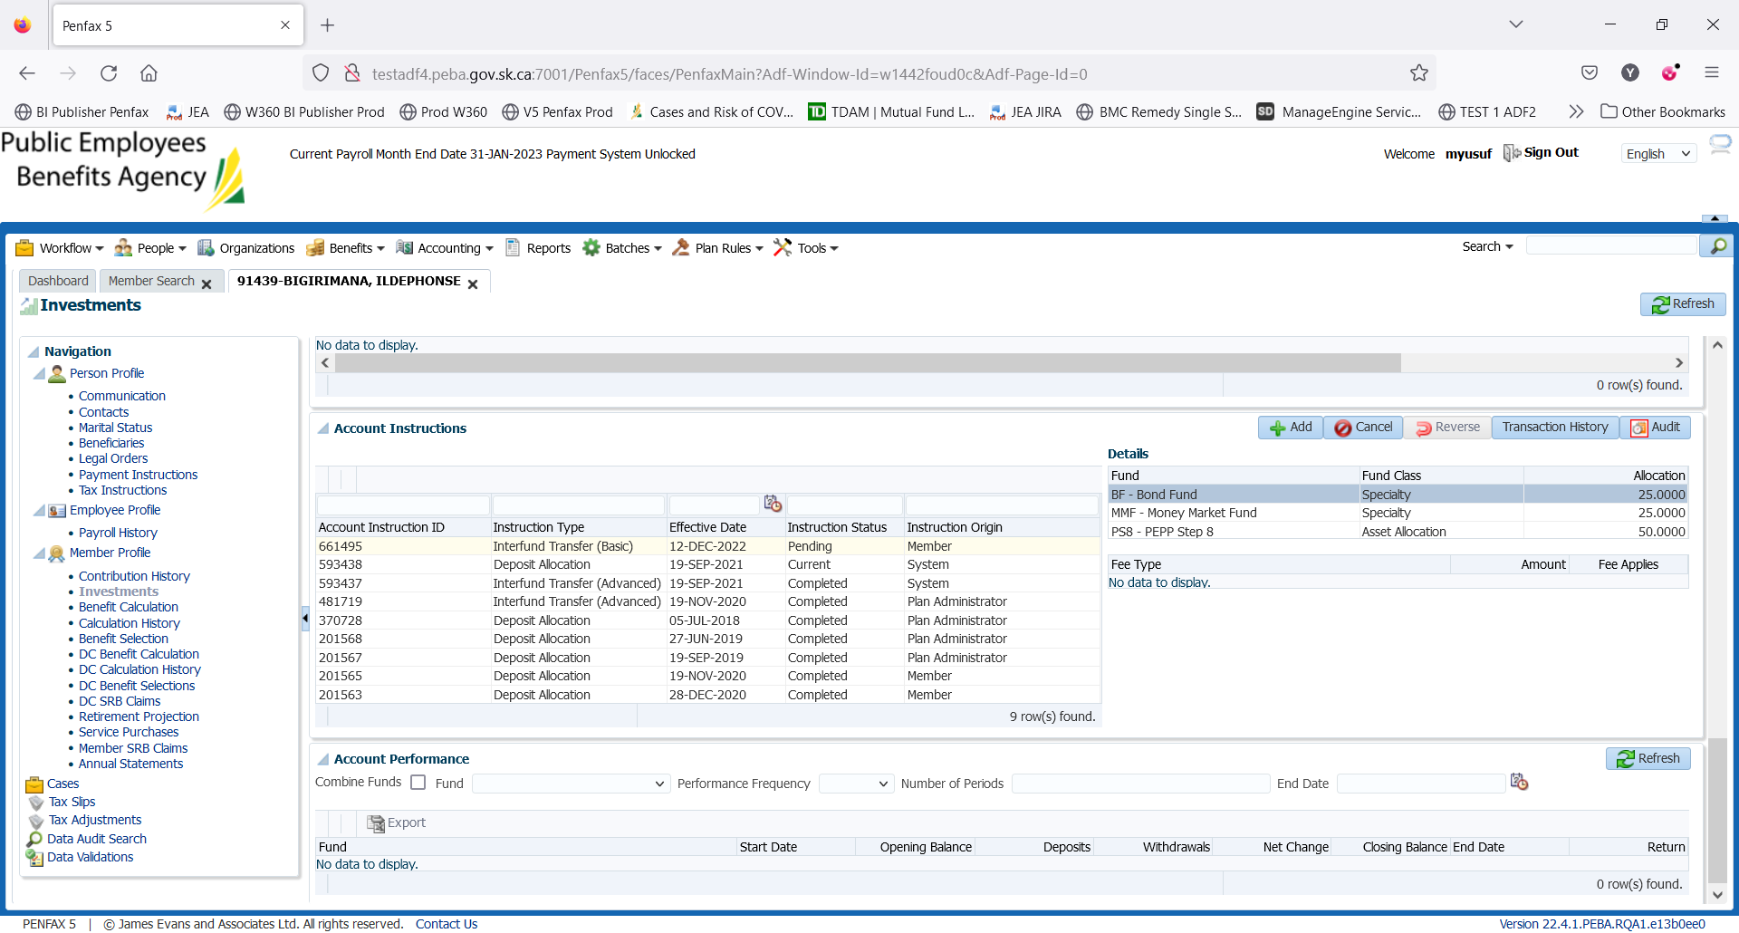

DAY 2

1. PIT batch was run overnight.
2. New DAI is now in current status but as Interfund Transfer was done in Member PLANet yesterday (May 25, 2022) after 2 pm, it will be processed on next day (May 26, 2022).

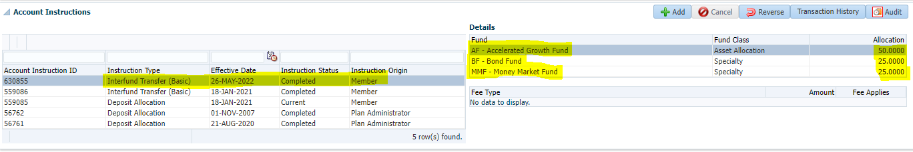

Transaction History of Interfund Transfer

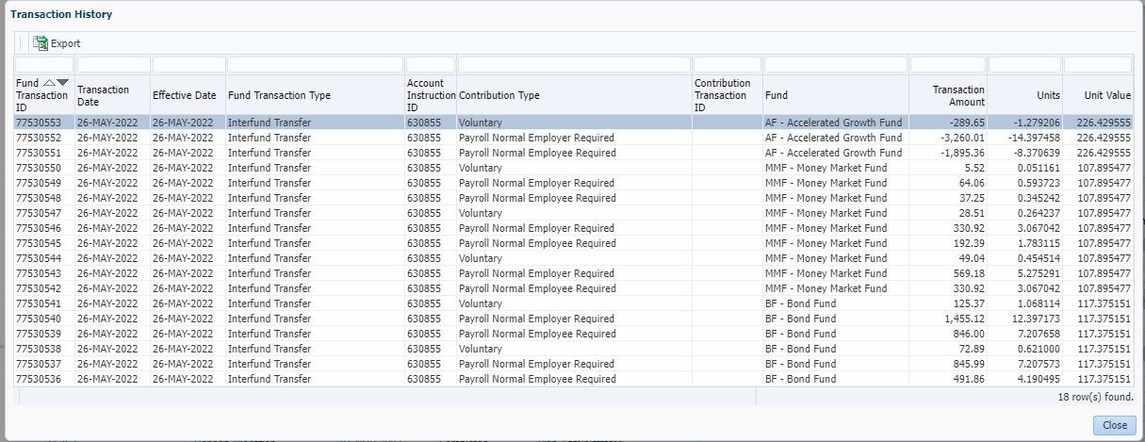

1. PEPP Interfund Transfer letter is available under Person Profile -> Communication -> Outbound Documents.

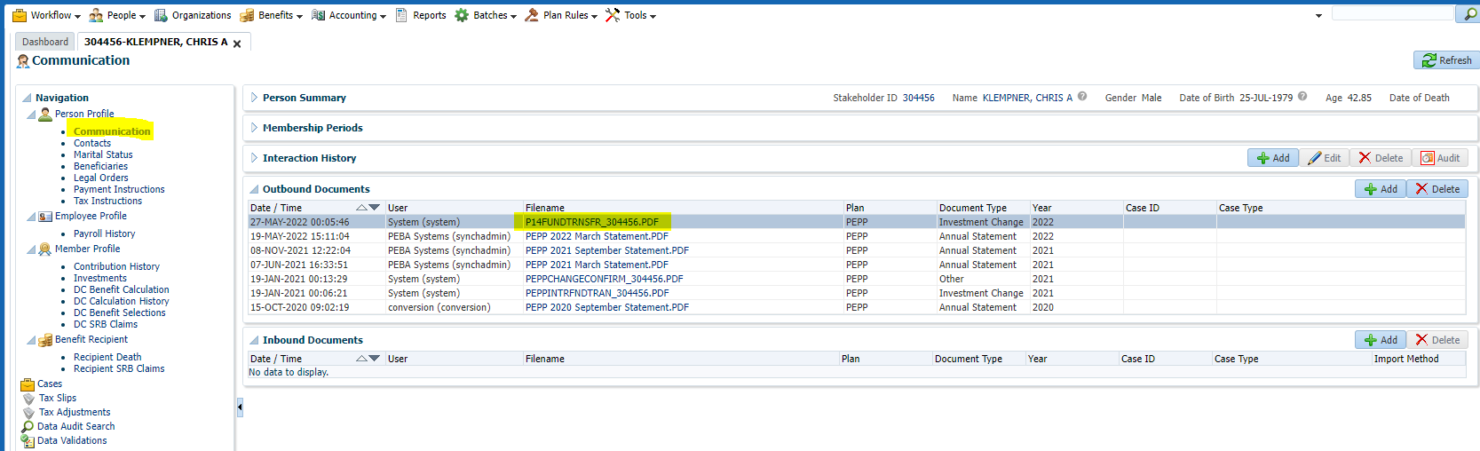

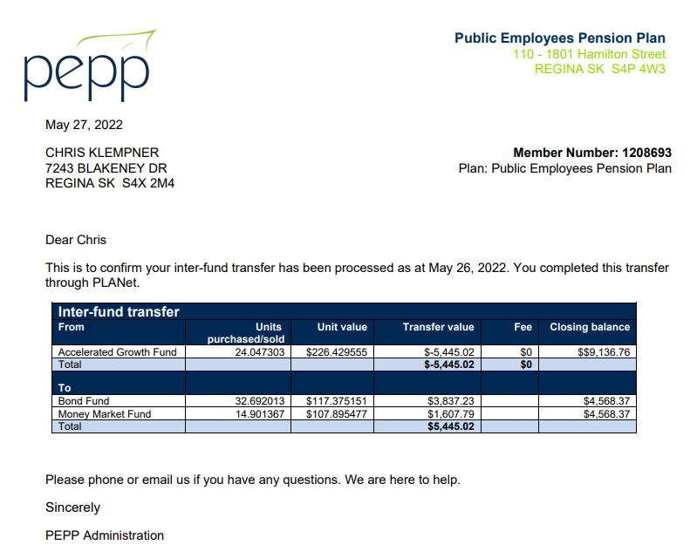

1. Check the Valuation Report. Go to Batches -> Batch Processes. Search with “PEPP Valuation Report” as Batch Process Type and open the very first record in the list (batch processed a day before).

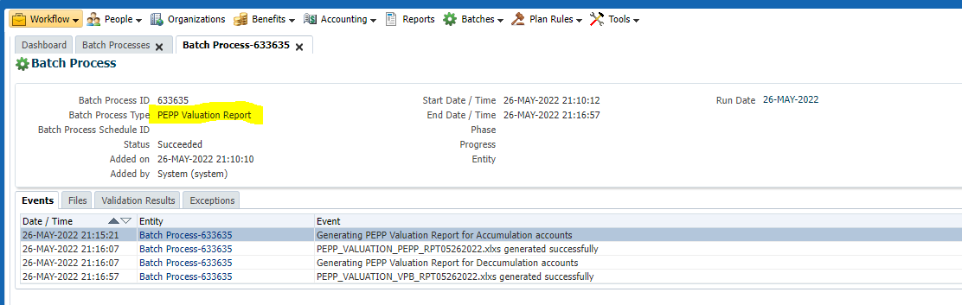

Go to Files tab and open PEPP valuation excel.

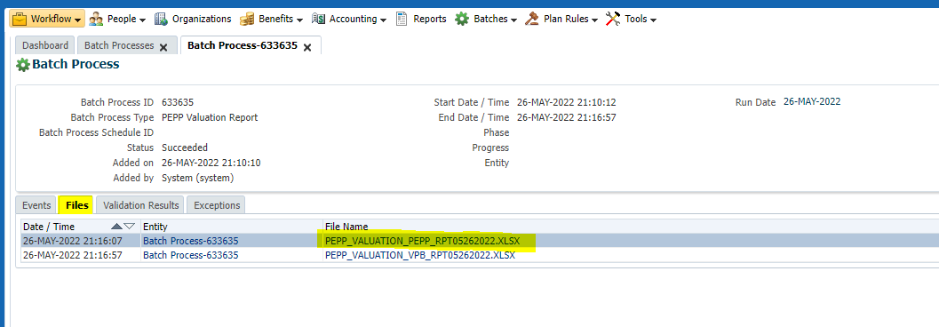

Section Four (Transfer In)

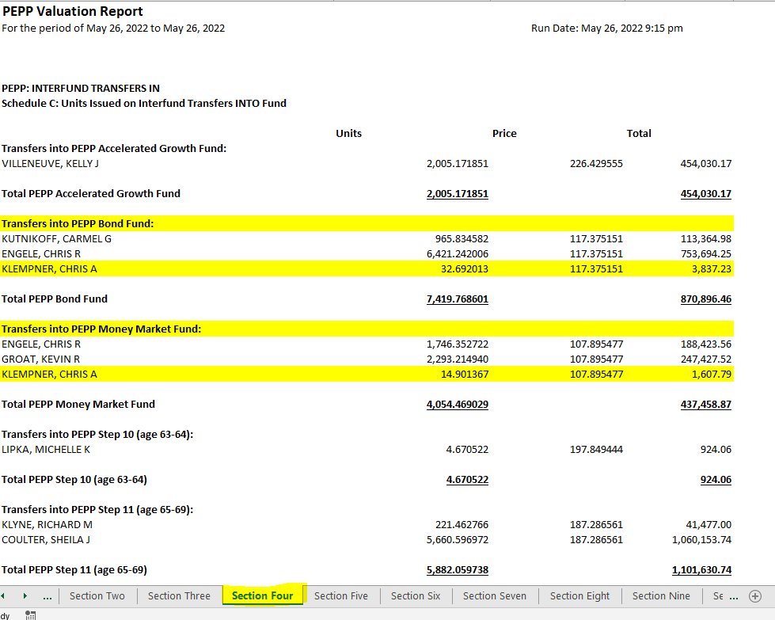

Section Nine (Transfer Out)

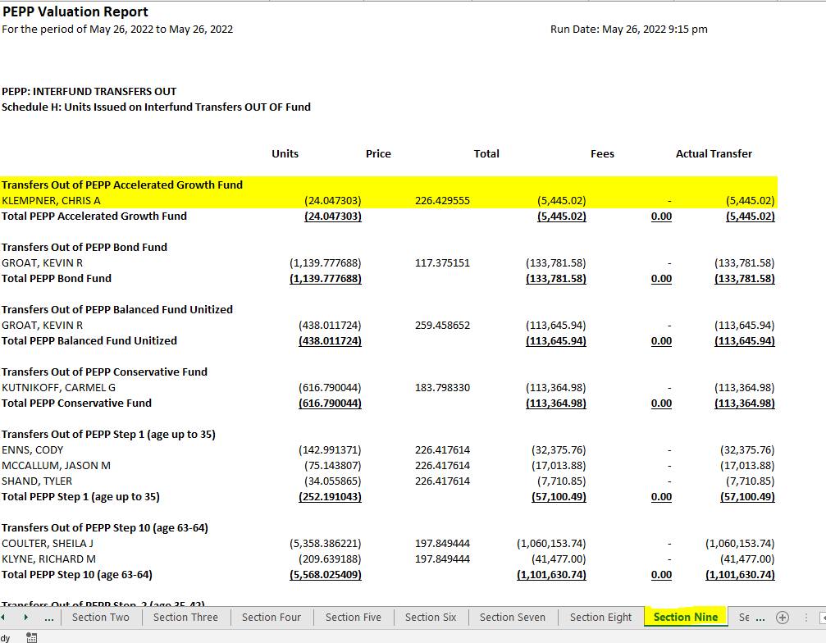

1. Member PLANet -> My Investment -> PEPP Account

